MQM Installation Guide

Following is a short installation guide for MQM. If anything is unclear please contact Datatex help desk at helpdesk@datatx.com.

Table of Contents

Part I: Downloading 2
Part II: Prerequisites 6
Part III: Installation 7
Installing the InterBase database: 8
Installing MQM: 10
Part V: Running in live mode 15
Configuration of the InterBase server 20
Part IV running in Demo mode - (only if you have the Demo DB) 21

Part I: Downloading
Connect to Datatex’s FTP server at 212.179.77.241
User: MQM
Password: MQMRELEASE
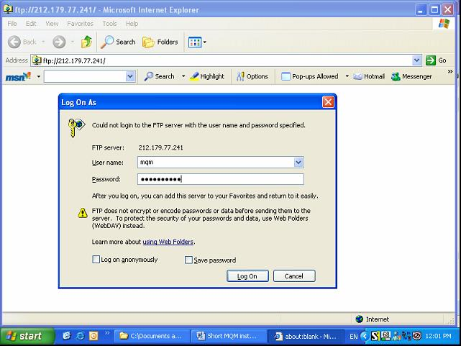
Fill the user name and password and hit ‘Log On’

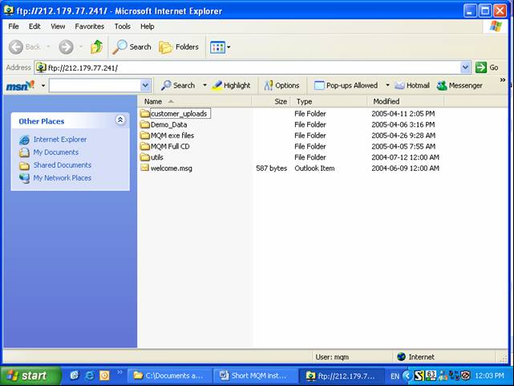
Select MQM Full CD and Right click with the mouse and chose ‘Copy to folder’
Select the place you want to keep the copied file, which will be used later for the installation.
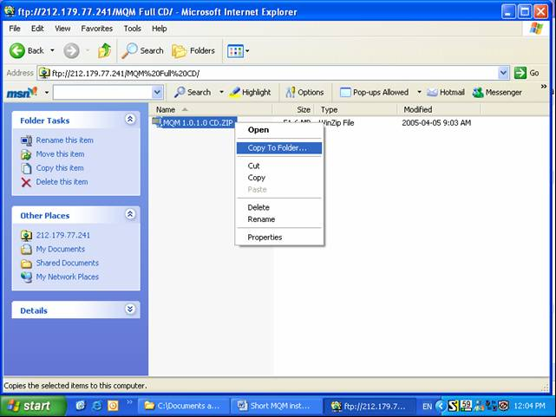
Chose a location
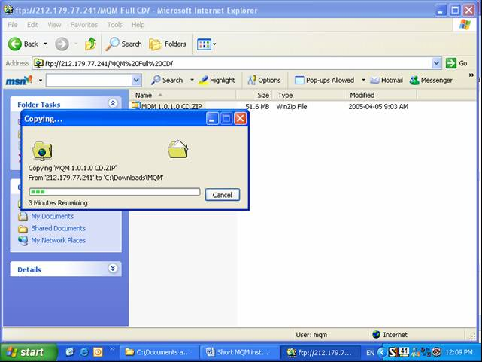

Close the FTP browser and Extract the downloaded file from the place you choose in the previous step.
- Go to folder MQM full CD there download the zip file named: MQM 1.*.*.*.zip (it's about 50 MB).
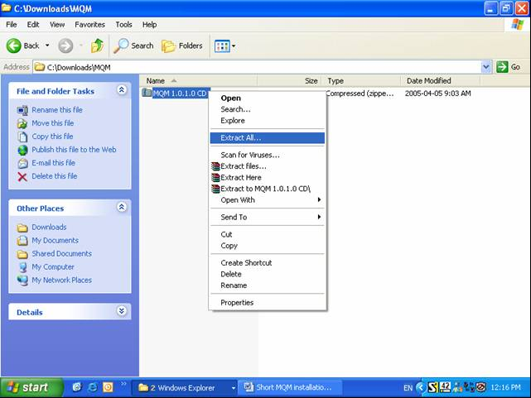

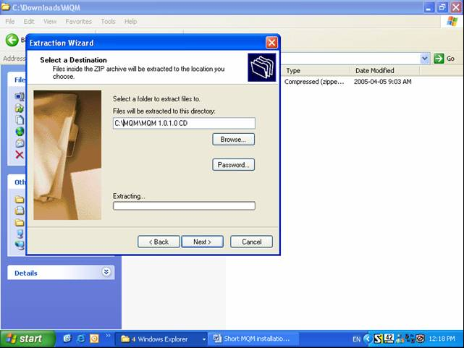
Press ‘Next >’

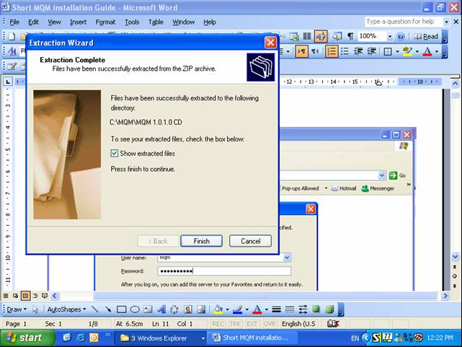
Press ‘Finish’.

Part II: Prerequisites
- For Demo purposes you need the files downloaded above plus demo DB files (which are available upon request).
- For live data you must have the MQM files on the AS/400, all MQM libraries and Client Access version 5 in order to download and upload data to/from the AS/400.
- The recommended OS is Windows XP, although it may run also on Win 98, which is not recommended.
- InterBase Server – a shareware edition is supplied together with the MQM installation CD; however it isn’t a server edition and will expire after 90 days. It is required to buy a InterBase server from Borland (www.borland.com/interbase)

Part III: Installation
- Inside the unzipped folder you will find a file named CD-start.exe - Run it and you will get a menu
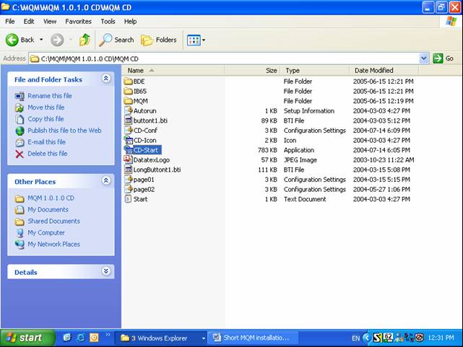
If InterBase is not installed already on your PC select ‘Install InterBase’
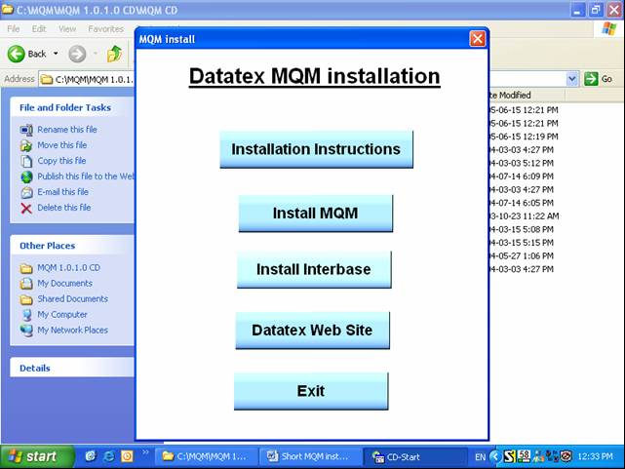

Installing the InterBase database:
In the menu choose Install InterBase Database.
When installing please leave all the defaults of the installation as are.
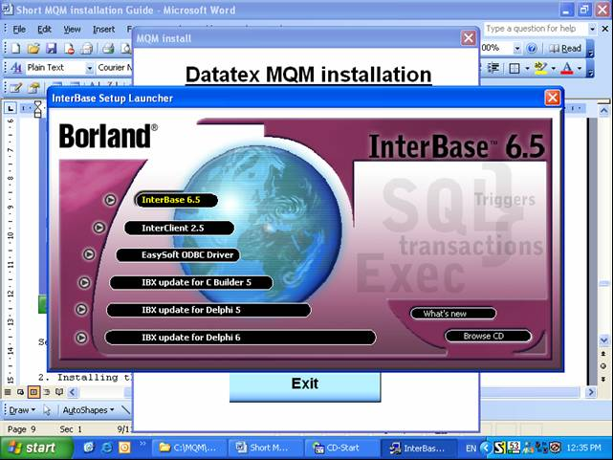
Select the first line. DO NOT CHANGE THE DEFAULTS

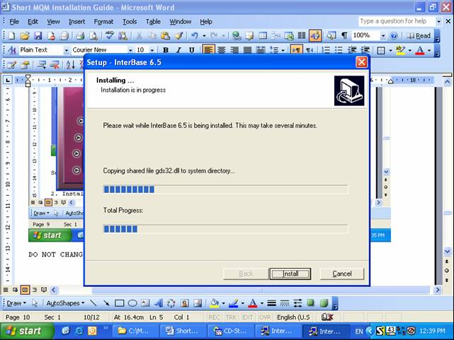

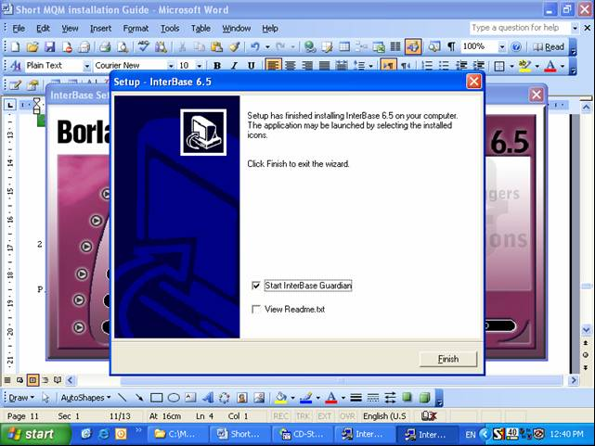
Press ‘Finish’.
Please verify that InterBase is running:
Go to Start | Control Panel | InterBase Manager
Verify that:
a. The startup mode is Automatic
b. The status of the InterBase server should be running (green)
c. It is recommended that the check box will be checked - run as Service
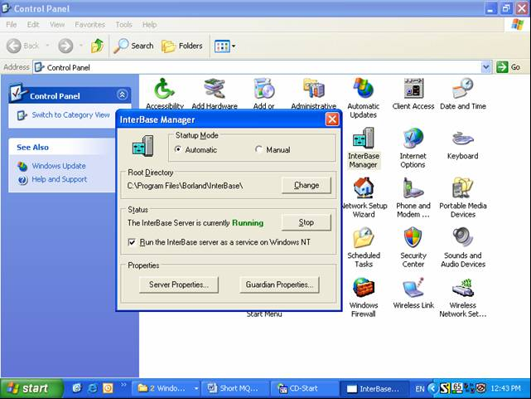

Installing MQM:
Return to the main/first screen, and choose Install MQM.
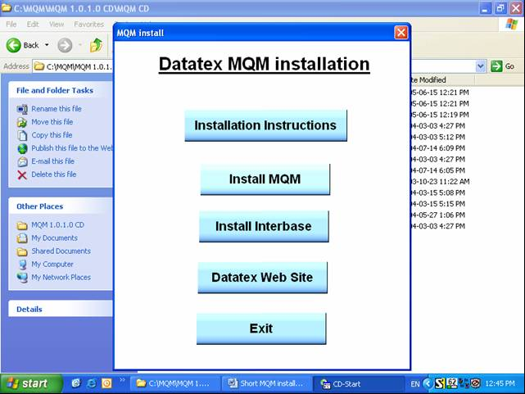
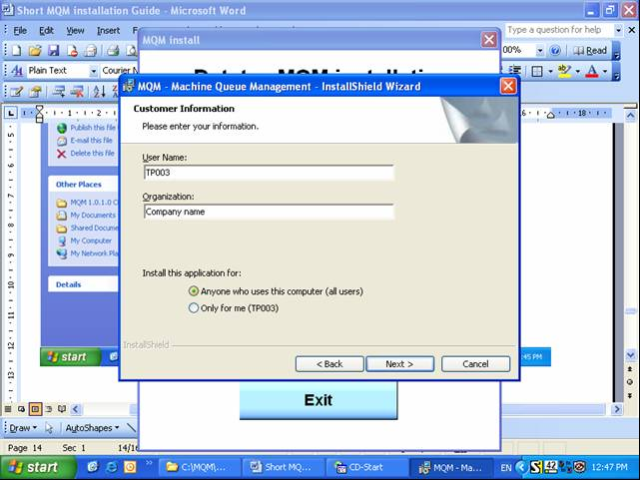
Fill in User name and Organization; press ‘Next >’

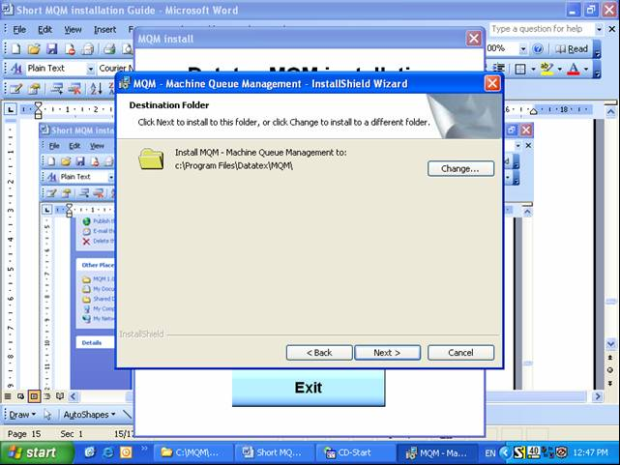
Press ‘Next >’ DO NOTCHANGE THE DEFAULTS.
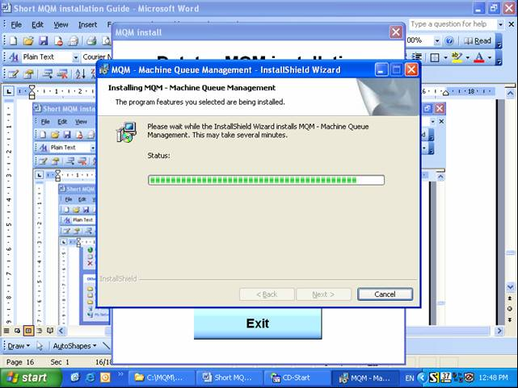

You should have now an MQM icon on your desktop and also in the programs menu you should have 3 programs (Start | All programs | Datatex | MQM |)
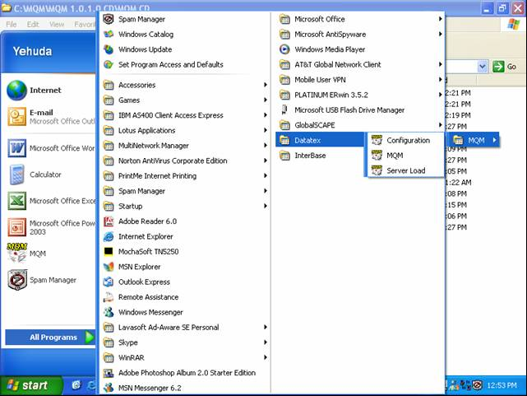

Select ‘Configuration’ and in menu 'Create' select 'Database', click on 'Create Configuration database'
Press OK, when you are getting a message.
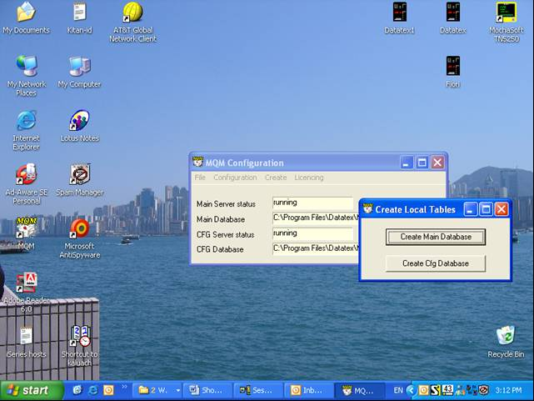

License:
When trying to work with MQM you shall get some strange message – until you get a license. Once the license is installed these errors should go away.
How to get a license:
Run MQM Configuration (some errors and messages about demo mode etc which can be ignored).
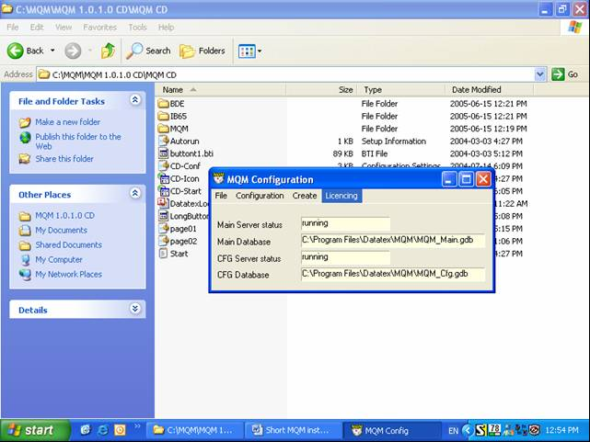

In the menu 'Licensing' select ‘Create Lock’ and save the suggested file in the default library and then send it to Datatex so the license can be issued (helpdesk@datatx.com).
Once you got the license you will have to run the MQM Configuration again.
In the menu 'Licensing' choose 'View License'. Click on 'Load'; point to the file you have received and click 'Install'.
That's it now you are done.
Please verify that the MqmUDF.dll is located in C:\Program files \Borland\InterBase\UDF

Create the ODBC connection: - (This is ONLY in order to work with the AS/400 - NOT the Demo alone)
Start | Control panel | Administrative tools | Data sources (ODBC) | System DSN tab
- click 'Add ', choose 'Client Access Driver ', click 'finish'
- General Tab: Data source name: MQM_AS400_DB and verify the AS/400 System connection IP address or name is correct.
- Server Tab:
Naming Convention: System naming convention (*SYS)
SQL default library: blank (remove the default value)
Library List: The Library list where you have MQM on the AS/400 - (E.g. TESMQM, TESMQMD and your data library)
Please note that, the library where you have the stored procedures of MQM should be on this list.
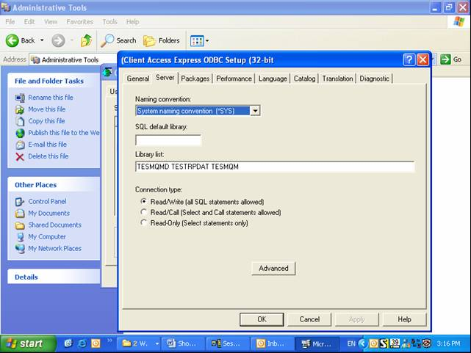

Part V: Running in live mode
If you want to work with your own data then you will need to run MQM_config and MQM_srvload.
MQM_config:
- In menu 'Create' select 'Database', click on 'Create Main database'.
When it has been created a small message will appear - close the Database window.
Now click on 'Create Cfg database' - when completed a message shall appear.
- In menu 'Create' select 'Stored procedures'
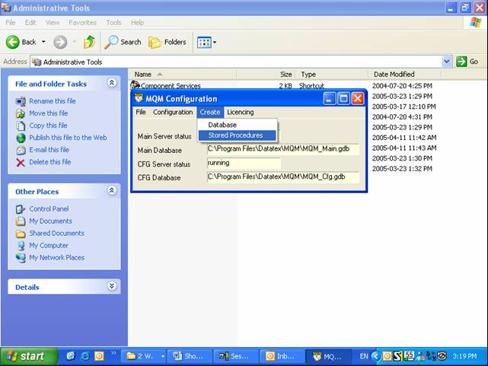
Press OK.
MQM_srvload:
- In menu 'Configure' select 'Stored Procedure' Tab, fill in the name of the library you wish to create the stored procedure on the AS/400 - The default is TESMQM .
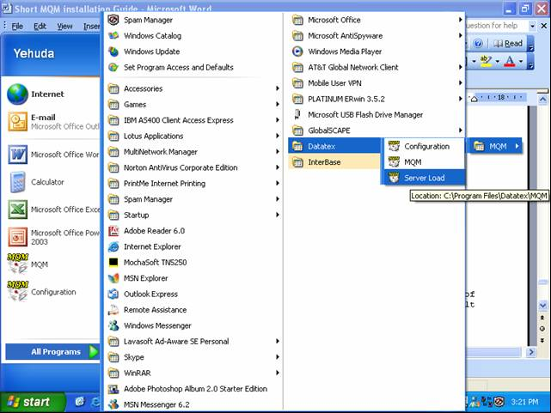

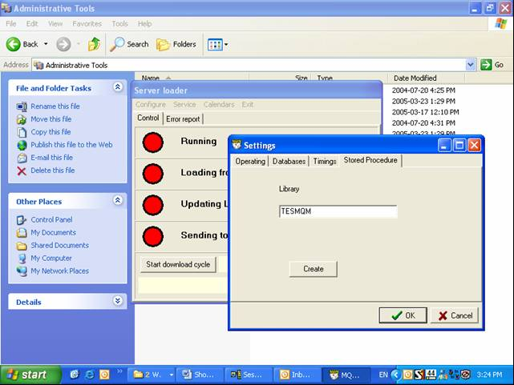
Please be sure to include this library in the ODBC connection library list.
Press Create and fill in the Username and Password to the AS/400.
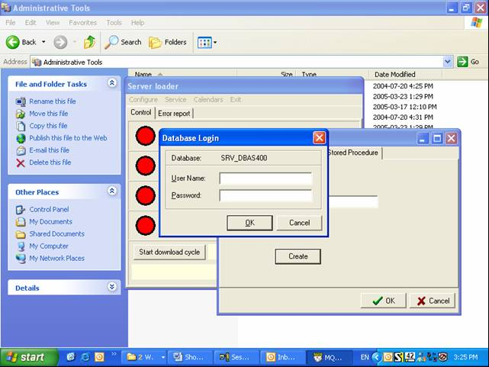
Press OK.
If you are getting an error message, press OK and OK again.

Load the calendar(s) –
Go to menu Calendars -> Load
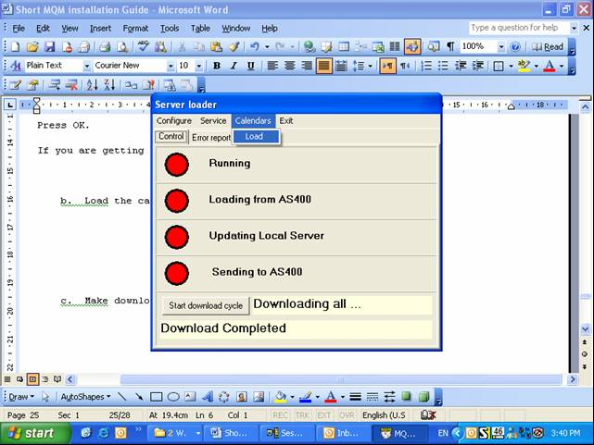
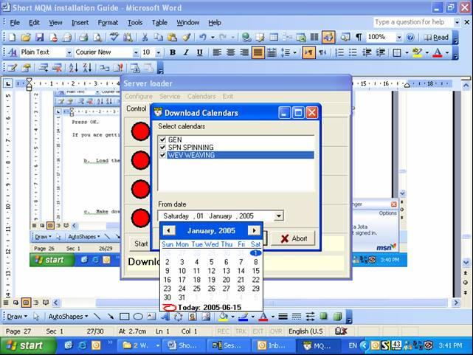

Make download –
Go to menu 'Service' -> 'Download'
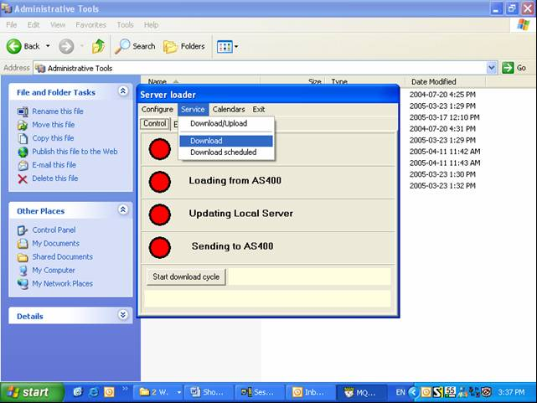
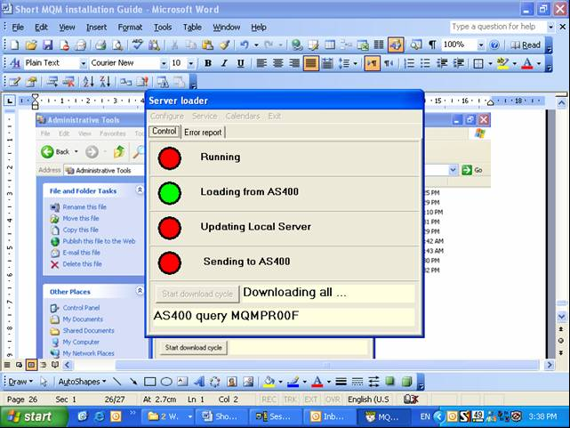

Select Configure | Timings tag and chose the Automatic Download cycle
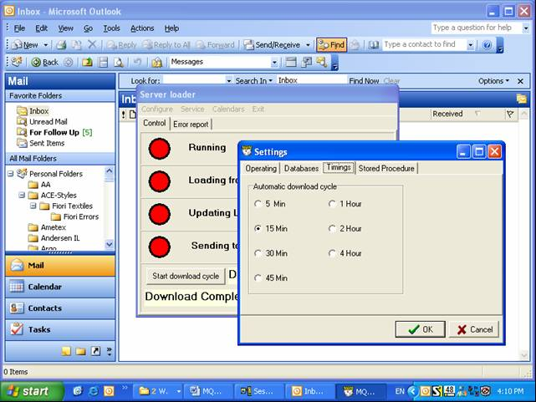
Press OK.

Configuration of the InterBase server
The Procedure of installation is almost the same as for the client; however here are the main issues:

- ONLY the InterBase server machine should have the MQM license. The client MQM machines don't need any licenses.
- It is required to install InterBase also on the client machines. You can install on the clients’ machine the InterBase version that comes on the MQM installation CD (Desktop edition).
Important: Do not try to use the InterBase on the clients’ PC. This installation has just one purpose: to have the InterBase connection drivers on the client PC, due, without them MQM can't connect to the Server and will crash. Therefore there is nothing to worry about that InterBase expiring on the clients’ machine since we are not using it at all - just the drivers.

- There are two ways to set MQM to connect to a remote InterBase server:

  - The official way is to run MQM configuration | settings | database. There you should have a form with 3 fields :
1- Server: here you should put the server IP or network name
2- MQM Main DB: full path to the folder where the DB resides on the server; + db name.
3- MQM CFG DB: full path to the folder where the DB resides on the server; + db name.
Please note it maybe required having these folders shared but it isn't a must.
  - The unofficial way is to edit manually the MQM.ini file. The file should have all three values (Server IP, and 2 paths). The file should be in the same folder of MQM.exe and is created by MQM itself.
Select Configure | Databases tab
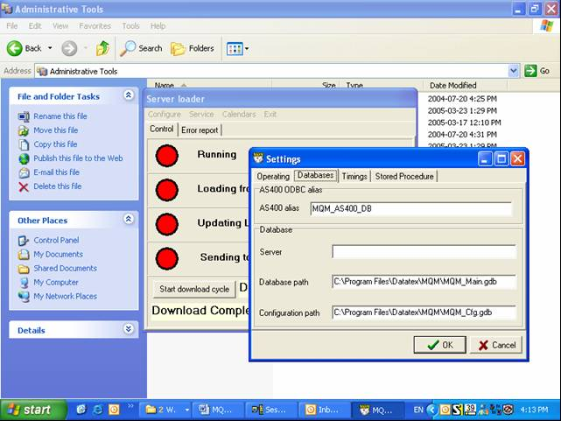
Important Notice:
InterBase database is a shareware product. Therefore there is a need to buy it separately. The version distributed with MQM will expire after 90 days. This version will support a maximum of 2 concurrent users connected to the server.

Part IV running in Demo mode - (only if you have the Demo DB)

There are 3 programs that are part of MQM:
Since you are not going to download data from the AS/400 you don't need 2 of them (MQM_config and MQM_srvLoad) but only need to run MQM.exe. You will have 3 optional workstations to work with and the password will be one of the following: ws1, ws2, ws3.
You will get a blank background, click on the third icon from the left 'edit tabs' press OK and you will get the Gantt. Do the same on the lower part of the screen - Bin - that is a right click on it.

